Jerusalem came to cause a dispute with Jesus. At issue was their observation that Jesus allowed His disciples to disregard the ceremonial law about eating with unwashed hands. King Saul had said untrue things about David, Isaiah was dismayed that the people weren't listening to God. Jesus quoted Isaiah to these people who were accusing Jesus (the Only-Begotten Son of God) of sinning against an obscure Law of God. Jesus point out that they were wrong, and while at it also pointed out that they willingly trashed one of the Ten Commandments when it was to their advantage. It is only out of concern for their salvation and in love, that we should point out the sins of others.

PRAYER OF THE CHURCH
℗ O God of mercy, You have canceled our debt of sin and have credited us with the pure righteousness of Your Only-Begotten Son. Raise us up each day as Your people and establish in us Your will. Enable us to do Your good works, so that we will do what is pleasing to You, not from our will but from Your pure and Holy will.
By Your Holy Spirit work in us a true and living faith in You and in Your Son Whom You sent. We know that even if we could fulfill one of Your laws we would do it incorrectly. In Your goodness and mercy we are seen by You, not having a righteousness which comes from any of our own work, but which comes from the Righteousness of Jesus.
Work in us a spirit of obedience to the example of our Lord Jesus Christ. Keep our words pure, our actions upright and our thoughts seeking Your peace. As we go through our life give us an ever stronger commitment and turning over of our will to You and Your higher purpose for us and all of creation.
Make our homes a sanctuary of Your presence. In that sanctuary, let Jesus Christ reign as sovereign supreme. Strengthen all parents, that they will be an excellent example, encouraging their children and youth in the practice of virtue, and service to You and to each other.
Pour out Your mercy on all who are in any trial or adversity, especially those who suffer for the sake of Jesus. Save them by Your mighty power. Bless our government and all useful commerce and industry. Help all people see that whatever they do, they are accountable to You.
Hear us as we bring to You our private petitions. (Time of silent prayer.)
Father, for the sake and in the name of Jesus Christ our Savior, forgive our sins and cleanse us that we are able to respond rightly to the proclamation of Your Word.
© Amen.
PROPER SIXTEEN

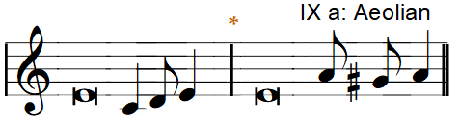
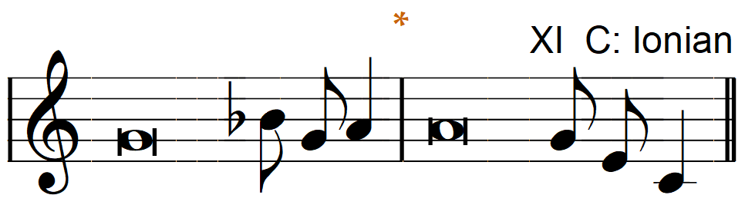
Chant Tone
Introit  O Lord, I love the habitation|of Your house*  and the place where Your|glory dwells.  Vindicate me, O Lord, for I have walked in my in|tegrity,*  and I have trusted in the Lord without|wavering.  Prove me, O Lord, and—try me;*  test my heart|and my mind.  I wash my hands in|innocence*  and go around Your altar,—O Lord, | proclaiming thanksgiving a—loud,*  and telling all Your|wondrous deeds.  Glory be to the Father and|to the Son*  and to the Holy—Spirit;  as it was in the be—ginning,*  is now, and will be forever.—Amen.  O Lord, I love the habitation|of Your house*  and the place where Your|glory dwells.  (Antiphon, Psalm 26:8;  Psalm 26:1-2, 6-7)

Collect of the Day
Almighty and merciful God, defend Your Church from all false teaching and error that Your faithful people may confess You to be the only true God and rejoice in Your good gifts of life and salvation; through Jesus Christ, Your Son, our Lord, Who lives and reigns with You and the Holy Spirit, One God, now and forever.

Gradual
Fear the Lord,|you His saints,*
for those who fear Him lack—nothing!
Many are the afflictions of the—righteous,*
but the Lord delivers him out|of them all.

(Psalm 34:9, 19, alternative)

Scripture quotations are from the Holy Bible, English Standard Version® ESV© Copyright© 2000; 2001 by Crossway Bibles, A Division of Good News Publishers, used by permission. All Rights Reserved.
ENTRANCE PRAYER: Praise and honor are due to You, our dear heavenly Father. You have brought us through many trials to this present hour. Your power and might have been our constant companions. In the Righteousness of Jesus Christ, You have heard our cries for help and answered our prayers. For Your constant care and watchfulness on our behalf, accept our praise and adoration. Through the power of Your Holy Spirit, help us believe that You alone have the Words of eternal life. Forgive all our sin for the sake of Jesus, that our worship is pure and Holy in Your sight. Amen (So be it, Lord.)

GOD'S LAW IS SOMETHING TO LIVE FOR AND IN. The Pharisees from Jerusalem came to cause a dispute with Jesus. Jesus called the whole crowd into the discussion. The issue of cleanness and uncleanness is not a matter of external symbols, it is what comes from within that makes us unclean. It is the attitude of our heart toward the message of Jesus Christ as the Only Begotten Son of God that will cause us to be Holy in the eyes of God. We welcome all who have been called out by the power of Jesus to be viewed as Holy in the sight of God the Father. We thank you for blending your voices together in praise of our Eternal king. If you are passing through we pray for your journey. If you are from near-by we invite you to join us every Sunday as we praise God for our Salvation.

THEME OF THE DAY
Honor the Word of God
INTROIT—(Antiphon: Psalm 26:8;) Psalm 26:1-2, 6-7
(We have moved the lessons around and are not in sync with the other Christians.) Psalm 26 was written by David while he was being persecuted by King Saul. Saul and his people were saying evil things about David. David asked God to show forth David's good heart, his innocence, as a way to combat Saul's evil words. When people speak unjust ill of us, we have God as our advocate.

COLLECT
Today we are most sincere as we ask to be taught by faithful people who will tell us the truth of God.

OLD TESTAMENT LESSON—Isaiah 29:11-19
This is a completely new lesson in the reading schedule. Isaiah was amazed at the stupidity of the greatest part of the Jewish nation. They had Priests, they had prophets, one would think, this was a great nation, that had all the advantages of divine revelation. But the Word of truth had become sealed. They could not discern the truth. Every vision Isaiah had seen for them, had become unintelligible. They were not alarmed with, nor affected by the Word of God. God knew their heart, and was not impressed with pretense. These people would be punished by seeing their enemies become faithful members of God's kingdom. This same issue is repeated in our Gospel Lesson. Lest you are sad, consider this as a prophecy of your salvation. We are the people who were the enemies of God who have, in the work of Jesus, been made His children.

GRADUAL—Psalm 34:9, 19 alternative
We continue with Psalm 34:9 and 19 to remind ourselves of fearless faith which comes to us in the power of Jesus.

EPISTLE LESSON—Ephesians 5:22-33
The command that all believers are to submit to one another is the foundation upon which all of Paul's observations about interpersonal relationships are laid. God commanded us to love one another. Paul compared the way that a husband loves his wive, as the commitment he has to his own body. This demonstrates what God has given to and for His church. God had special delight and pleasure at being God as He accompanied the salvation of the fallen. We realize our humanity in the fullness of being claimed by Christ as His bride.

GOSPEL LESSON—Mark 7:1-13
We have divided this lesson from our past practice and spread it across three Sundays. Jesus was in Galilee. The Pharisees and Scribes from

